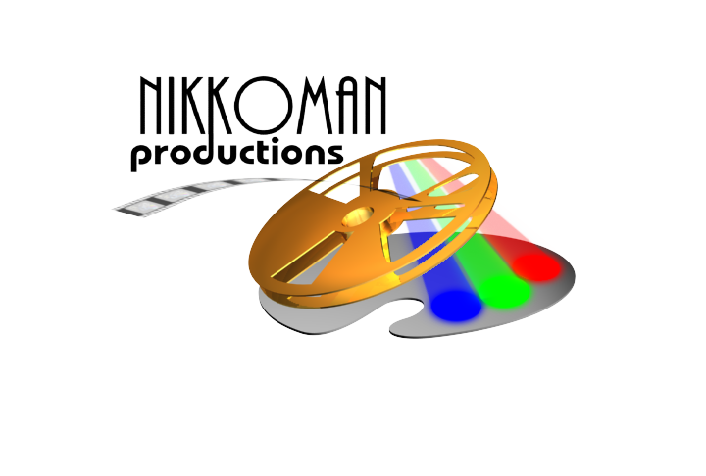
HD/SD EDITING FACILITIES

Avid and Final Cut Pro are the applications used to create more of the world’s films, television shows, and commercials than any other editing system.

Input/Output:

HD-SDI, SD-SDI, Component, Composite, Firewire

Available Formats:

Video: VHS, SVHS, 3/4”, Hi-8, Mini DV, DVCam, DVCamPro, DVCPro, DVCPro HD, Betacam SP, Betacam SX, DigiBeta

Audio: DAT, Casette, CD

RATES

w/Editor $150.00/hr
Weekly $1,200.00
Monthly $2,500.00

Contact Nik Stanjevich @ 562-420-6564
NS@NikkoMan.com

Terms:
- NET 30 ON APPROVED ACCOU NTS. ALL OTHERS IN ADVANCE.
- CANCELLATION POLICY ENFORCED: 24 HOURS OR LESS @ 100%
48 HOURS OR LESS @ 50%

